**Homework 01: Naïve Bayes’ Classifier**

**1. Discrete Features** 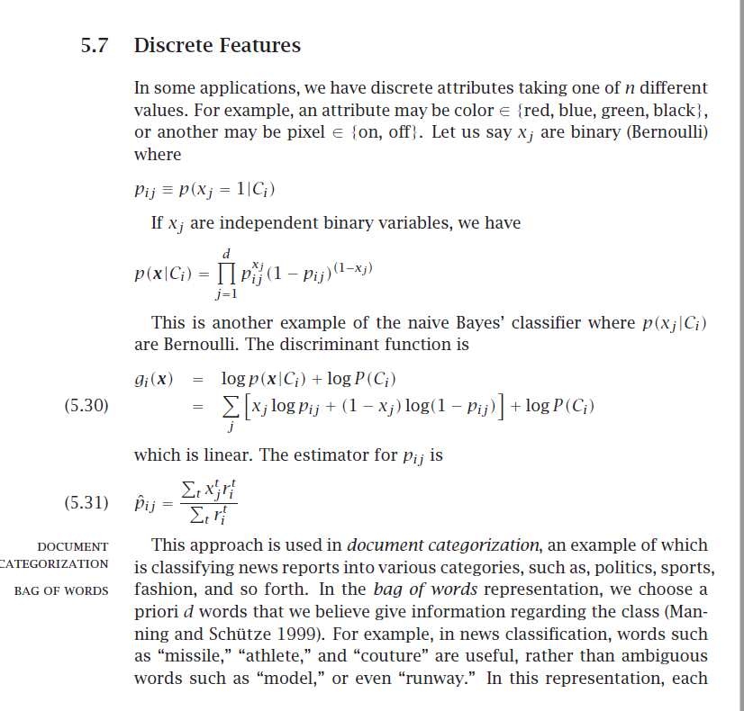

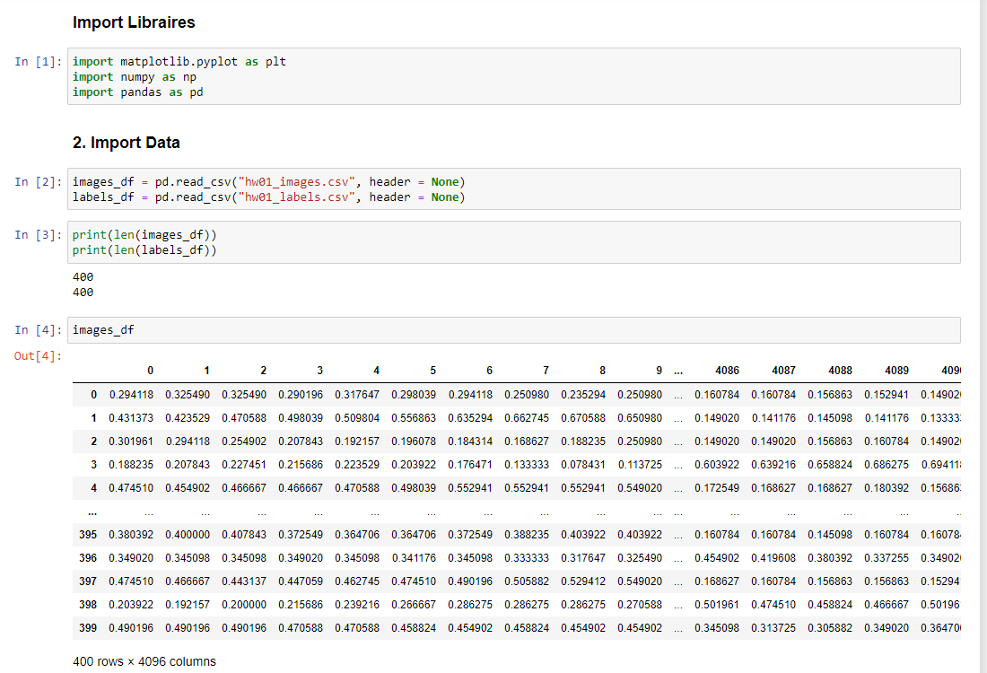**2. Import libraires than read image and label data from csv.**

**3. Divide the data set into two parts by assigning the first 200 images to the training set and the remaining 200 images to the test set.**

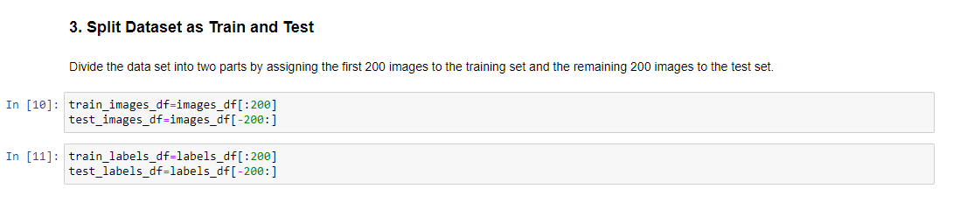

**4.** **Estimate the mean parameters, the standard deviation parameters, and the prior probabilities using the data points you assigned to the training set in the previous steps**.

Sample Means Calculation for each class and each pixel pairs.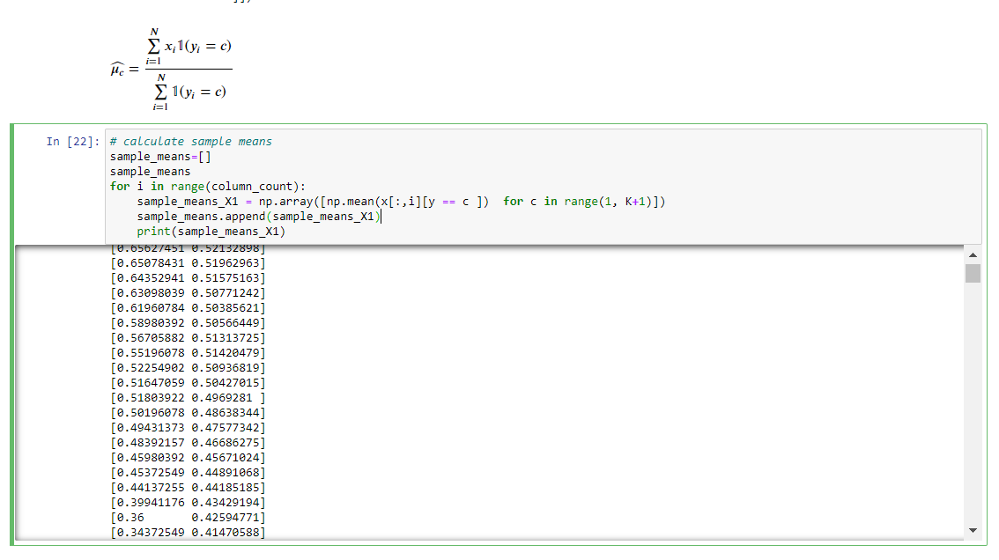

Sample Means of Women and Men

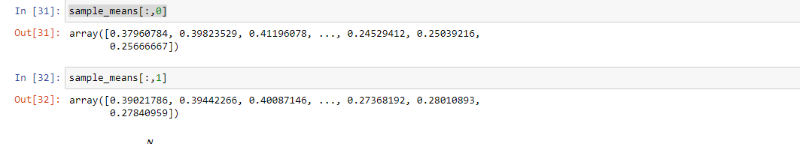

Prior Probobilities of each class (women, men)

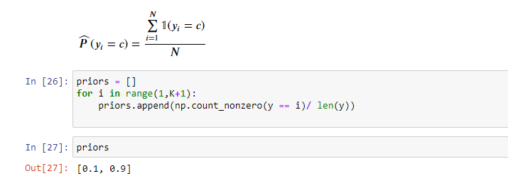

Standart Deviations Calculation for each class and each pixel pairs.

